

**e-Yantra Robotics Competition - 2018**

**Task 3C: Theme and Implementation Analysis HC#3266**

|  |  |
| --- | --- |
| **Team leader name** | Mahantesh.R |
| **College** | PES University |
| **Email** | mahanteshr17@gmail.com |
| **Date** | 25-12-2018 |

**Scope and Preparing the Arena**

**Q1 a. State the scope of the theme assigned to you. (2)**

The theme assigned to our team is named as “HOMECOMING”. Its main goal is to create a miniature model which includes an arena consisting of habitats, animals and an autonomous robot to negotiate a path on the arena to identify the different animals and habitats by making use of machine learning models, which then picks up the animal from the arena and through path traversal places that animal in its respective habitat.

* The theme can be used to model an animal park, where animals are transported to their respective habitats.
* This model could be used in wildlife tourism like safari etc where tourists could be guided to a particular habitat based on the animal they wish to see.

1. **Attach the Final Arena Images. (3)**

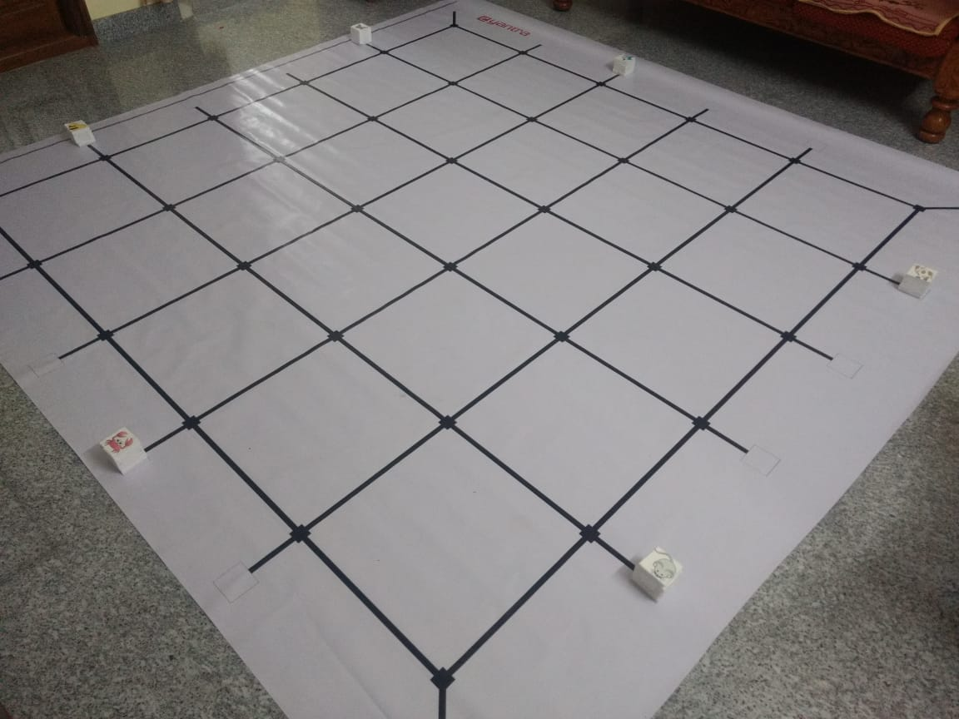

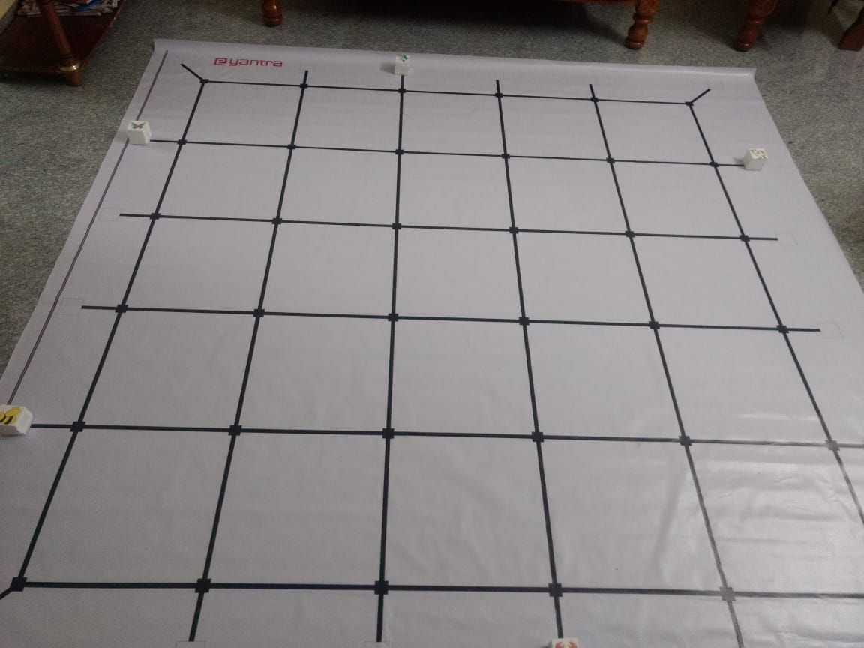 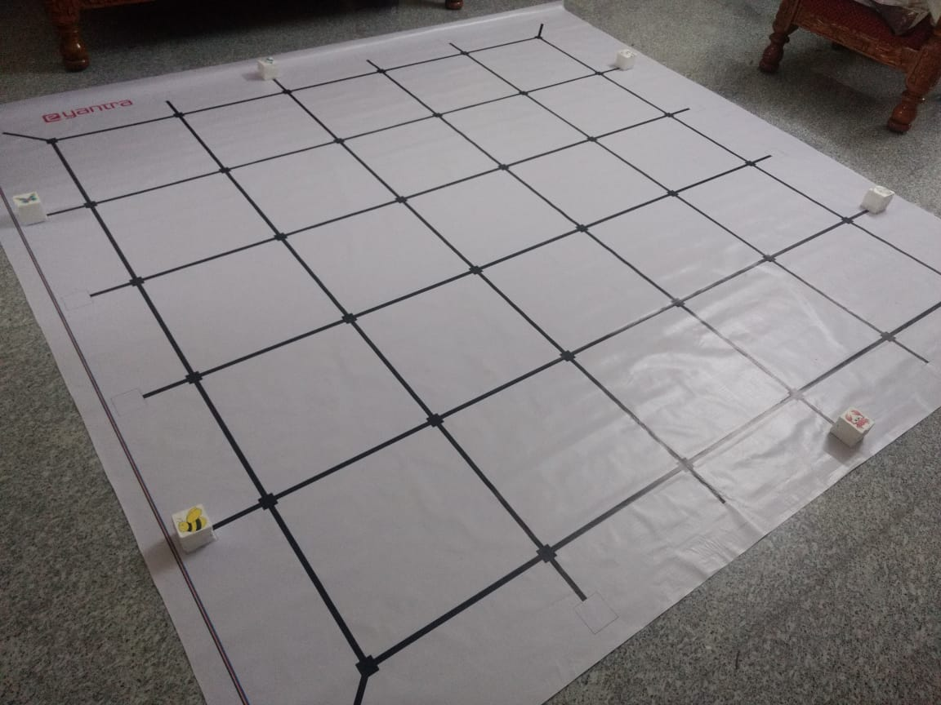

**Building Modules**

**Q2. Identify the major components required for designing the robotic system for the solution of the theme assigned to you. (3)**

***Mechanical systems***:-

* A Robotic arm which makes use of servo motors (based on the requirements). The robotic arm is programmable and its purpose to is to pick the animal from its location and place it in its habitat. The movement of the arm is controlled by servo motors which can be programmed.

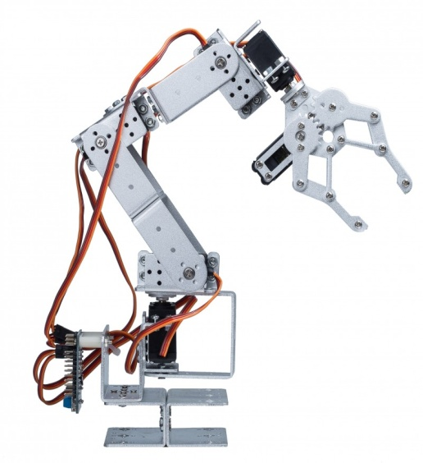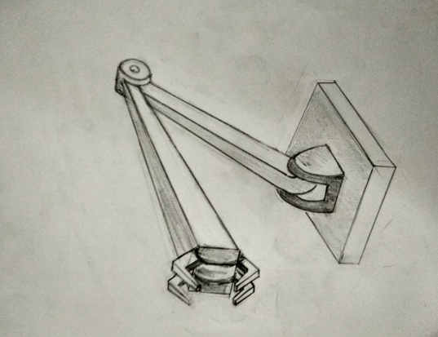

***Electrical systems:-***

* **White line sensors:** These are required for traversing the firebird V on the arena’s path starting from a point to an animal’s location and from there to its respective habitat.
* **Infrared proximity sensors**: These are required to detect the animal block/obstacles.
* **Sharp IR range sensors**: These are required to precisely measure the distance between the robot and the animal block.

***Indicators:-***

* **Buzzer**: Once all the animals are placed in their respective locations the robot sounds a continuous buzzer to indicate that task is completed.

**Design Analysis**

**Q3.** **Teams have to design an arm mechanism for deposition of the Animals in their respective Habitats.**

1. **Choose an** **option to position this mechanism on the robot and why? (2)**
2. **Front 2. Back 3. Right/Left**

**Answer: __________Front__________**

In our opinion the robotic arm on the Front side of the robot is a convenient position, as it would be comparatively easy for the robot to pick the animals from their locations, other options like Right/Left aren’t preferred because there are animals on the corner of the arena too, which would be a little troublesome as the robot would have to rotate by certain angle etc and would also cause the robot to lose balance, which are minimized if we place the arm on front side. Back side isn’t preferred because we need to interface the arm with robot, so we make use of the ports on the rear end and placing arm there would cause hindrance.

1. **Explain the design of the mechanism and how it is mounted on the robot. Also explain what challenge/s do you expect to face and how you will overcome them? (6)**

The robotic arm would consist of 2 servo motors, one which would be used for the vertical movement of the arm, allowing it to swing vertically and another servo motor would be used to pick the animals from their locations and drop it in the respective habitat. The mechanism is such that when the robot reaches a particular animal location the robotic arm moves vertically down from its initial position by making use of one servo motor and by using another servo, the arm picks up the animal block from its location with its clip like arms and holds it. The arm would swing upward and the robot would traverse to the respective habitat of the animal on the arena and as it reaches its habitat location the arm would swing downward and the clip like arms would open and hence the animal would be dropped in its respective habitat.

One of the challenges is to design the arm such that it doesn’t obstruct the movement of the robot or cause it to lose balance. The arm also needs to be calibrated to pick up the animals with precision and drop them exactly inside their habitat nodes. The movement of the arm must be smooth and continuous and should avoid any jerks that may drop the object or cause the robot to change direction. Taking precise measurements and running several trials is one way to address this issue.

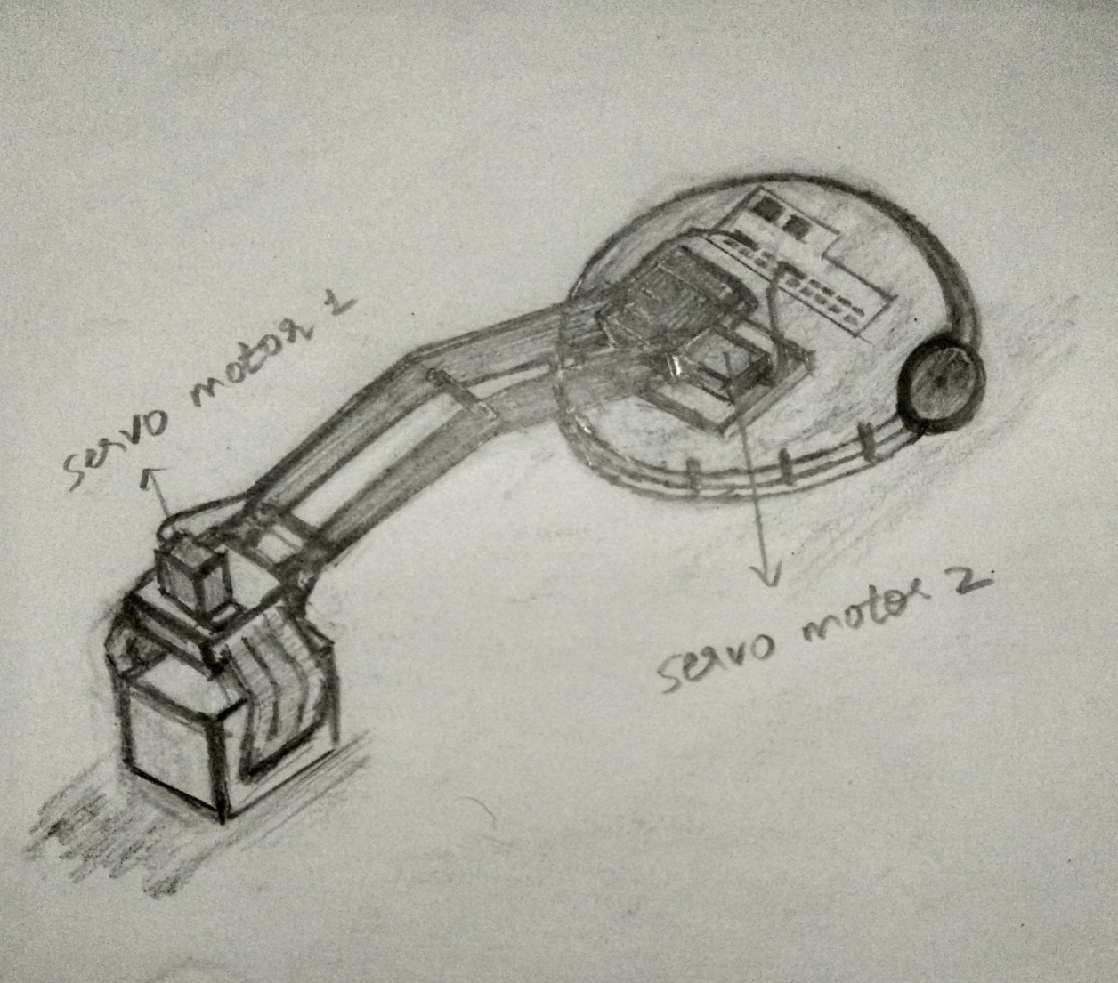

1. **Choose the actuator/s you will use to design the mechanism. (2)**
2. **DC-Motor 2. Servo Motor 3. Stepper Motor 4. Others**

**Answer: ______Servo Motor___________**

Servo Motor is preferred primarily because it is programmable and it immediately turns to whatever angle the controller instructs it to, regardless of the initial position at power up, whereas in a DC motor equal step angles cannot be obtained constantly. Stepper motor is an open-loop position control system without any feedback, and it requires the controller to know its initial position on power up.

**Environment Sensing**

**Q4. Explain how you will use the provided sensors to implement the theme. (2)**

The sensors that are going to be used are:

* **White line sensors**
* **Sharp IR range sensors**
* **Infrared proximity sensors**

White line sensors - White line sensors are used for detecting white line on the surface. Firebird V has 3 white line sensors. White lines are used to give robot sense of localization. These white line sensors are mounted on the front side of the robot and they continuously send the readings to the computer. If the sensors detect a reflection value nearly equal to zero (indicating black line), the robot is programmed to move forward. If any of the sensors read higher value then the robot is made to adjust its position by rotating by a small angle in the opposite direction to the sensor that sent the reading, until it is in a position such that the readings of the 3 sensors are all nearly equal to zero. In this way the robot traverses the entire arena.

Sharp IR Range sensors – The robot can have up to 5 sharp IR range sensors mounted on it with one of them present at the front. This sensor can be used to estimate the distance to the objects and provide an estimate for the path that can be traversed quickly.

Infrared proximity sensors – The robot can have up to 8 infrared proximity sensors mounted on it. These are used to overcome the blind spot of Sharp IR range sensors. In the blind spot of Sharp IR range sensors the Infrared proximity sensors detect the obstacle (animal block) and the arm picks up the animal. Next the robot traverses the arena to reach the destination (habitat block), where the arm drops the animal.

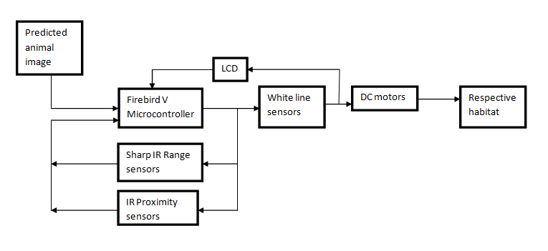

**Testing your knowledge (theme analysis and rulebook-related)**

**Q5.** **What is the purpose of “activation function” in a Neural Network? How do different types of activation functions affect the network? (5)**

An activation function is basically a mathematical function which is really important for an ANN to learn and introduce non-linear complex functional mappings between the inputs and response variable. They introduce non-linear properties to our network*.* Their main purpose is to convert an input signal of a node to an output signal**.**That output signal now is used as an input in the next layer in the stack i.e. sum of product of inputs(x) and their corresponding weights (W) is calculated and an activation function f(x) is applied to get the output of that layer which is fed as input to the next layer.

If activation functions are not used then the output signal would just be a simple linear function which are of less complexity and have less power to learn complex functional mappings from data.

Neural Networks are supposed to learn and represent any general set of data and hence an activation function is required to make the network more powerful and add ability to it to learn something complex.

Activation functions have the property of causing a small change in the output for a small change in input, which is crucial to learning.

Another important feature of activation function is that it should be differentiable so that it could be used in backpropagation for optimizing the weights and biases.

The different types of activation functions used in a neural network are –

* Sigmoid function
* Softmax function

**Sigmoid function** – It is an activation function of the form

Its range is from 0 to 1 and it’s a S-shaped curve as shown:

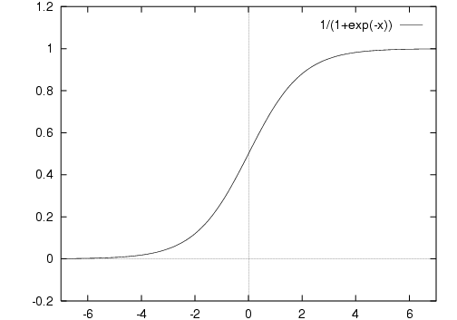

Normally, sigmoid functions are used in the hidden layers

This function’s output is not centered at 0 which causes the gradient updates to go too far in different direction.

Sigmoid function has slow convergence, it saturates and kills gradients causing vanishing gradient problem.

These demerits cause decrease in accuracy and performance of the neural network.

**Softmax function** – It’s an activation function which is a generalization of logistic regression given by

The softmax function is generally used in the output layer of a neural network and trained under cross entropy regime. The softmax function squashes the outputs of each unit to be between 0 and 1, but it also divides each output such that the total sum of the outputs is equal to 1.

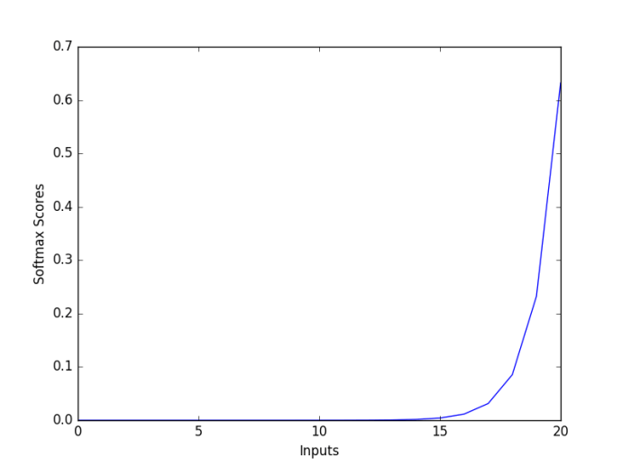

**Q6. What are the different hyper-parameters in a CNN that affect its performance? Explain the different parameters and their effects (in bulleted form). (5)**

Hyper-parameters are a set of variables that determine/define the CNN. The different hyper-parameters are:

* **Batch Size** -> The training samples are grouped into batches which is the number of sub-samples given to the network per iteration, after which the parameters are updated. Its influence on the CNN in terms of performance and accuracy is considerable, i.e. having a large batch size increases the performance and may alter model’s accuracy. The batch size can be any one of two options:

Mini-batch or Stochastic mode

* **Learning Rate** -> This parameter defines how quickly a neural network learns or updates its parameters (weights and biases). Learning rates can be dynamic or remain fixed throughout the learning process.

A low learning rate slows the performance of the model but maintains a decent accuracy.

A high learning rate speeds up the performance comparatively but the accuracy drops down.

Fixed/adaptive learning rate adjusts the learning rate such that the model is optimized in regard with performance as well as accuracy.

* **Number of epochs** -> It is the number of times the whole training data is passed to the network while training. Increasing number of epochs increases the accuracy while there’s a drop in the performance of the network.
* **Number of hidden layers and units** -> Increasing the number of hidden layers increases the accuracy of the network, while it may degrade the performance of the model.
* **Momentum** -> Momentum helps to know the direction of the next step with the knowledge of the previous steps. It helps to prevent oscillations. A typical choice of momentum is between 0.5- 0.9.

**Q7. Why are the first few layers of a CNN hard to train? (3)**

Considering a neural network that consists of more than one hidden layer with weights & biases initialized randomly, it is found that the neurons in the ‘i’th hidden layer learns quite a bit faster than the neurons in ‘i-1’th hidden layer, i.e. the learning rate is high for final hidden layers. Adding more hidden layers would cause the early hidden layers to learn more slowly compared to the ones near final layer which overall causes trouble in training the network. The gradients tend to get smaller while moving backward through the hidden layers due to the vanishing gradient problem.

**Algorithm Analysis**

**Q8. Draw a flowchart illustrating the algorithm you propose to use for theme implementation. (12)**

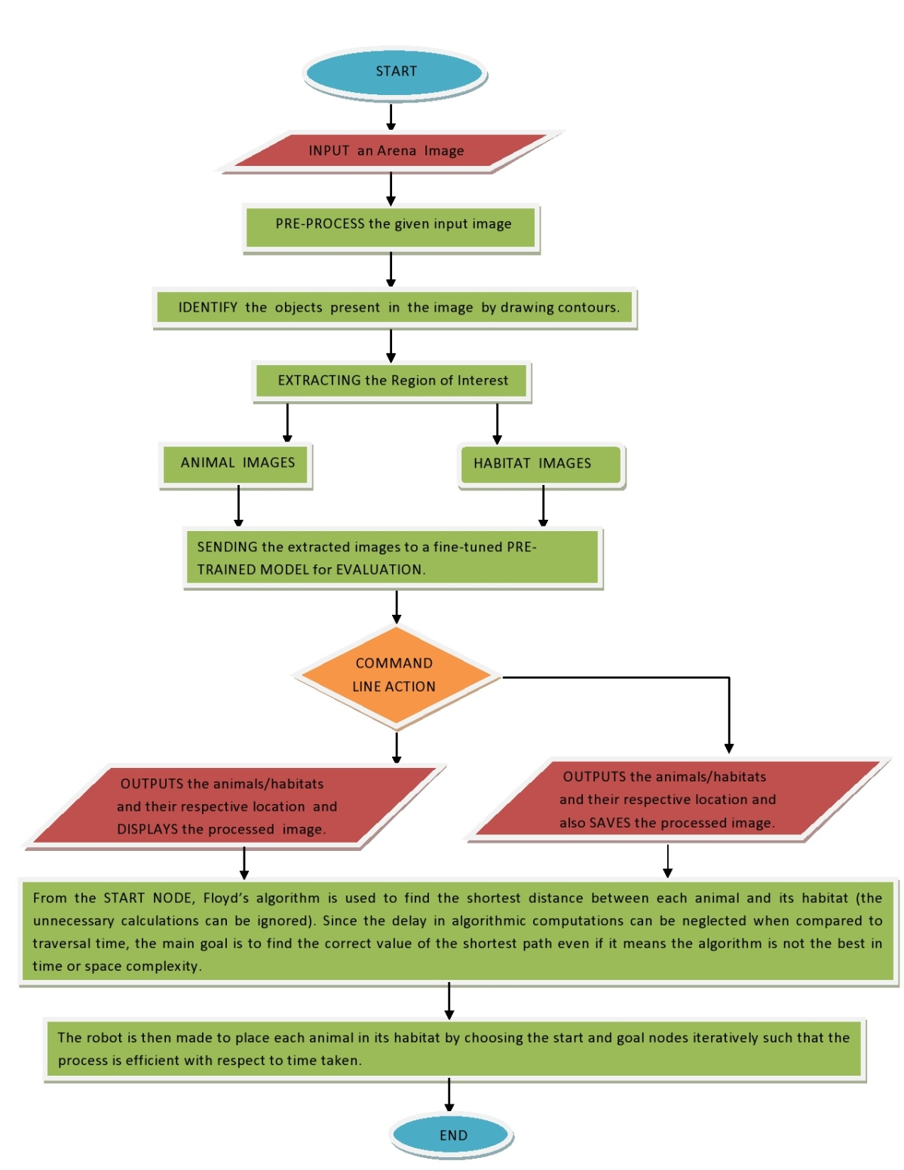

**Challenges**

**Q9. What are the major challenges that you can anticipate in addressing this theme and how do you propose to tackle them? (5)**

* Design and calibration of the robotic arm: One of the challenges is to design the arm such that it doesn’t obstruct the movement of the robot or cause it to lose balance. The arm also needs to be calibrated to pick up the animals with precision and drop them exactly inside their habitat nodes. The movement of the arm must be smooth and continuous and should avoid any jerks that may drop the object or cause the robot to change direction. Taking precise measurements and running several trials is one way to address this issue.
* Calibrating the sensors and setting appropriate threshold values: It is necessary to calibrate the white line sensors, Sharp IR range sensors and the proximity sensors to avoid bumping into obstacles along the path. Also the calibration should accurately judge the distance between the robot and the animal so that the arm can pick it up correctly and drop it.
* Proper training of the model: The prediction model should be trained adequately so that it can accurately identify the animals and their habitats. Choosing the right activation functions, selecting the learning rate value, adjusting the parameters, and fine tuning the model to achieve the best possible result are also challenges that must be addressed. Varying the learning rate and number of epochs by trial and error method till best result is achieved is an approach to solve this problem.
* The choice of path finding algorithm: It is important to choose the best suited algorithm for this theme to find the most efficient way to transport each animal in the arena to its habitat. Factors like space and time complexity, accuracy of the result etc are to be considered when making this choice.
* Turning precision of the robot: When traversing the arena, the robot must make several precise turns to complete the task which involves the movement of the DC motors. The robot must also stay on the path (black line) during its traversal.